**MICROSOFT FABRIC INTEGRATION WITH POWER BI**

Introduction:

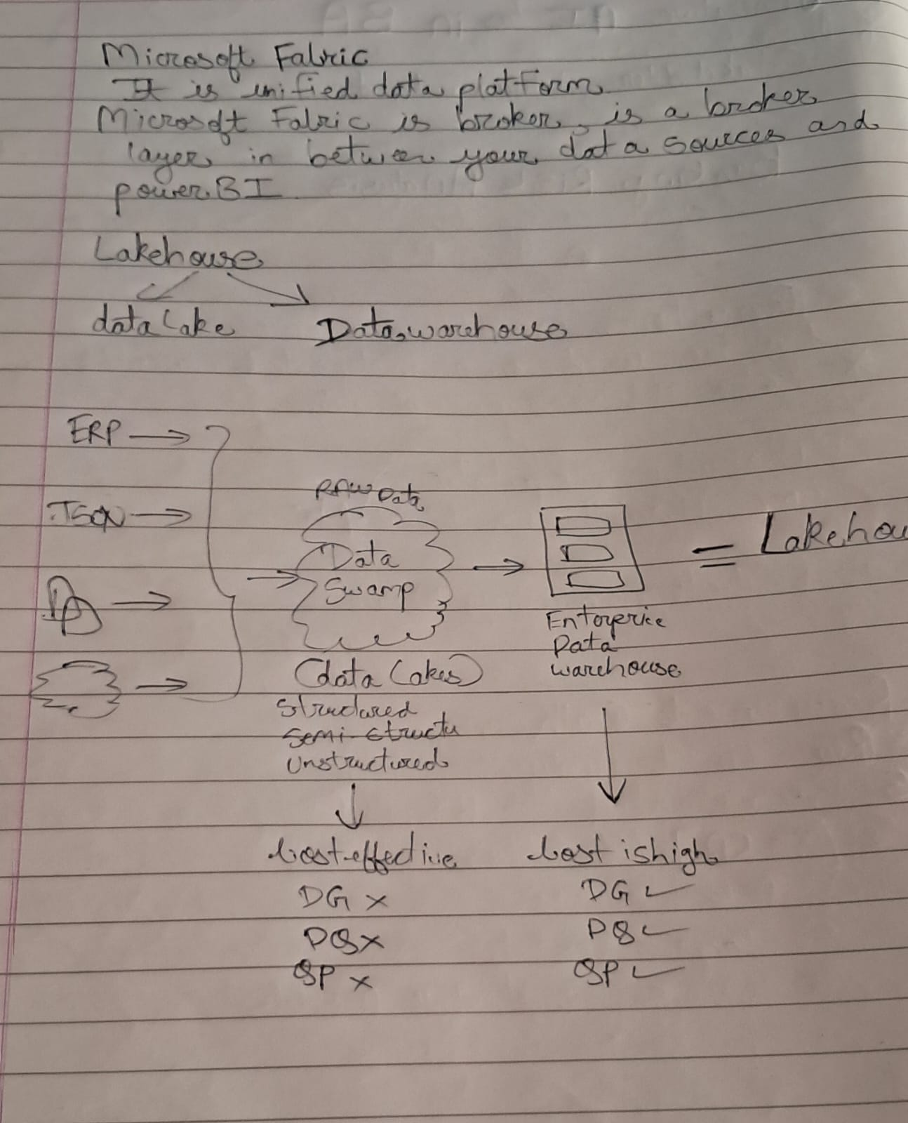

MICROSOFT FABRIC HOME PAGE

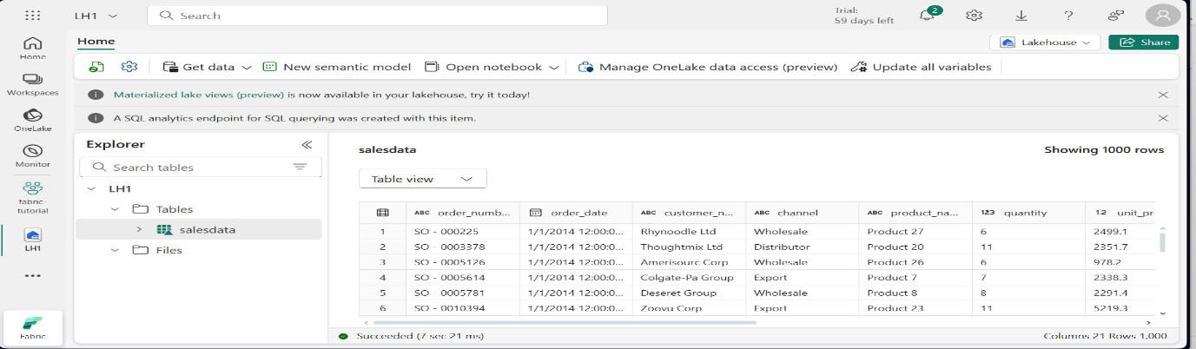

MICROSOFT FABRIC CONNECTION WITH LAKEHOUSE

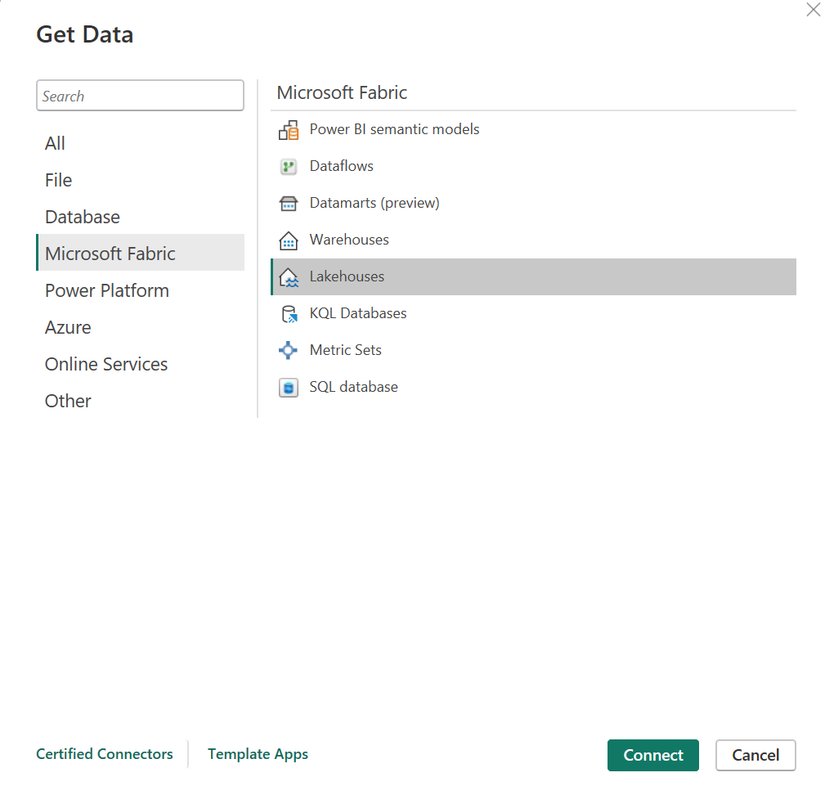

CONNECTION ESTABLISHED

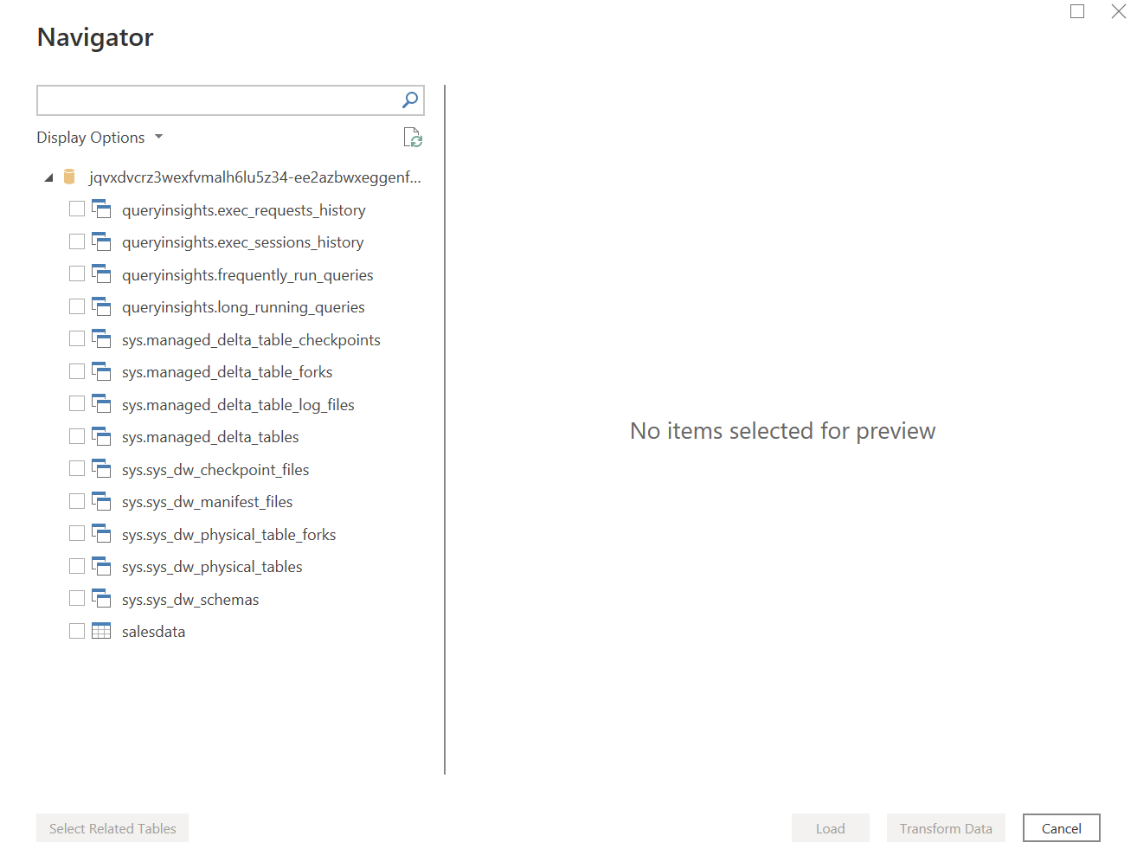

DATA LOADED IN POWERBI VIA FABRIC

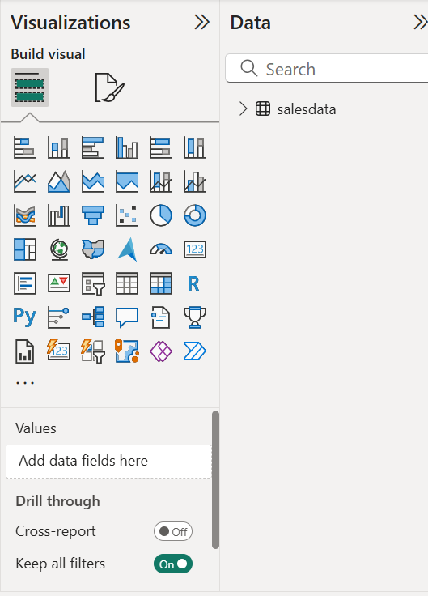

KQL CONNECTION WITH ADX( ADOBE Data EXPLORER) USING DUMMY CLUSTER

https://help.kusto.windows.net

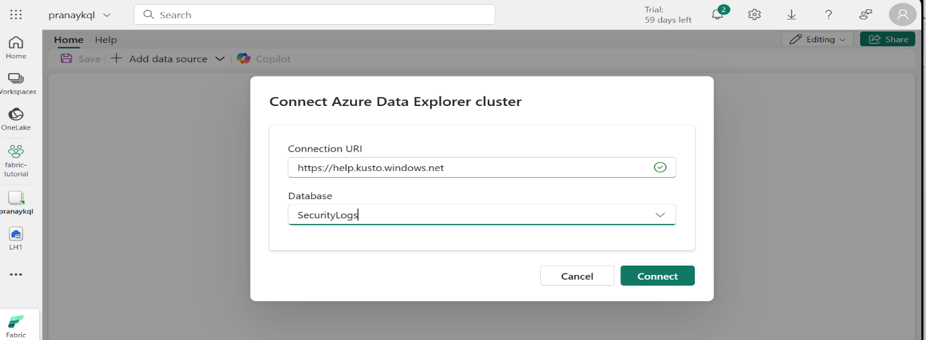

**KQL(KUSTO QUERRY LANGUAGE)**

INTRODUCTION:

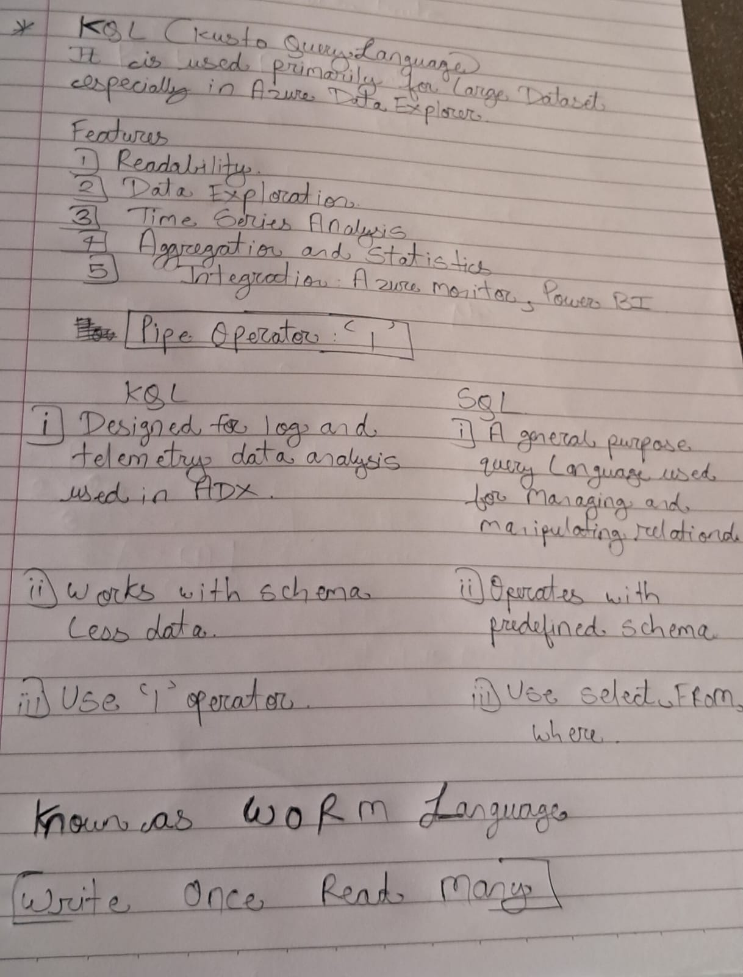

KQL PRACTICAL

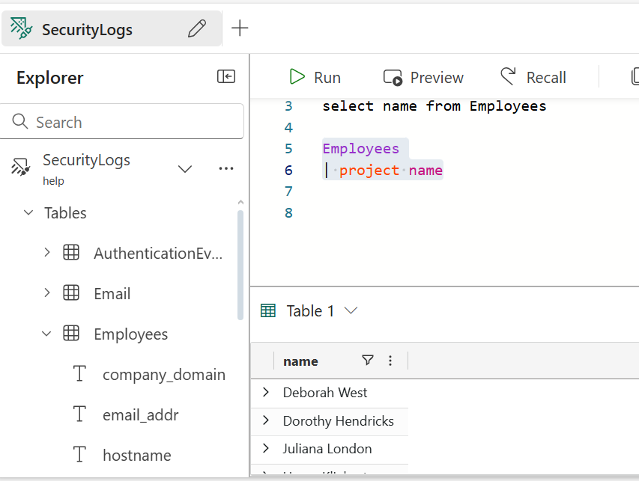

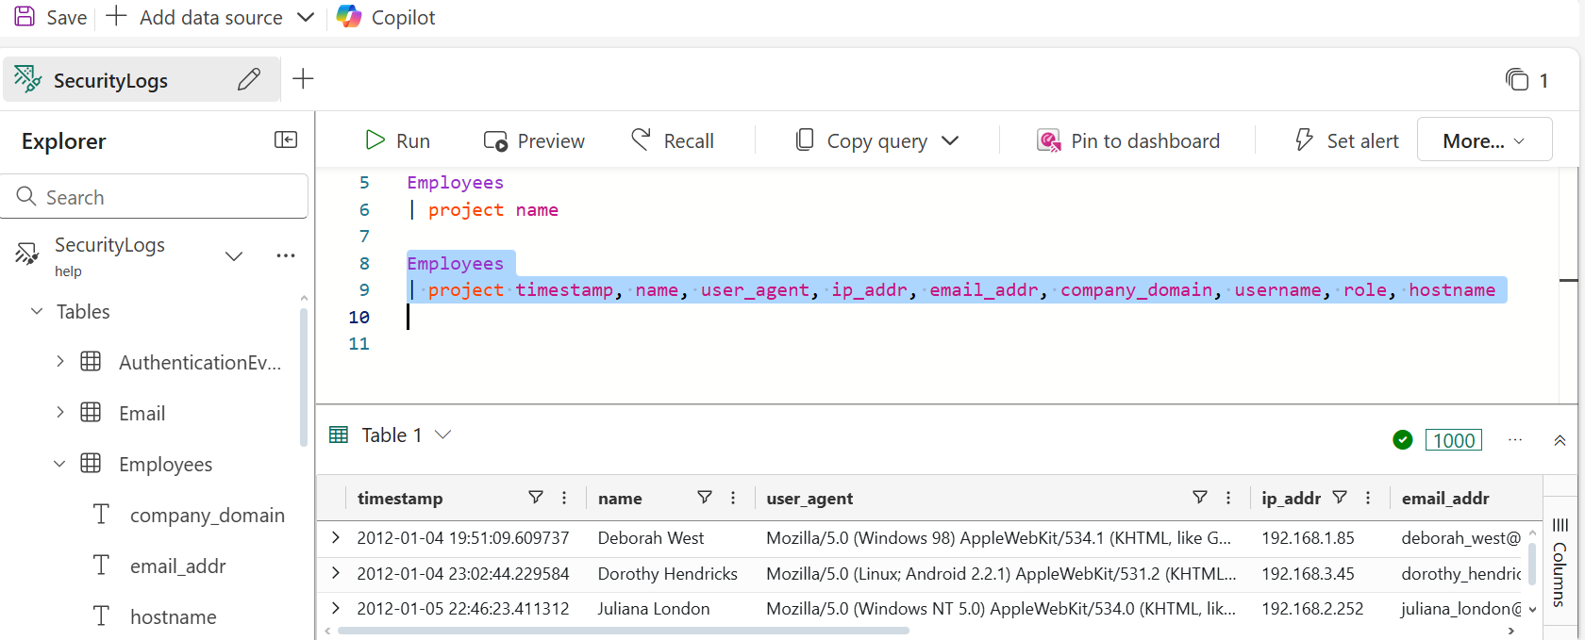

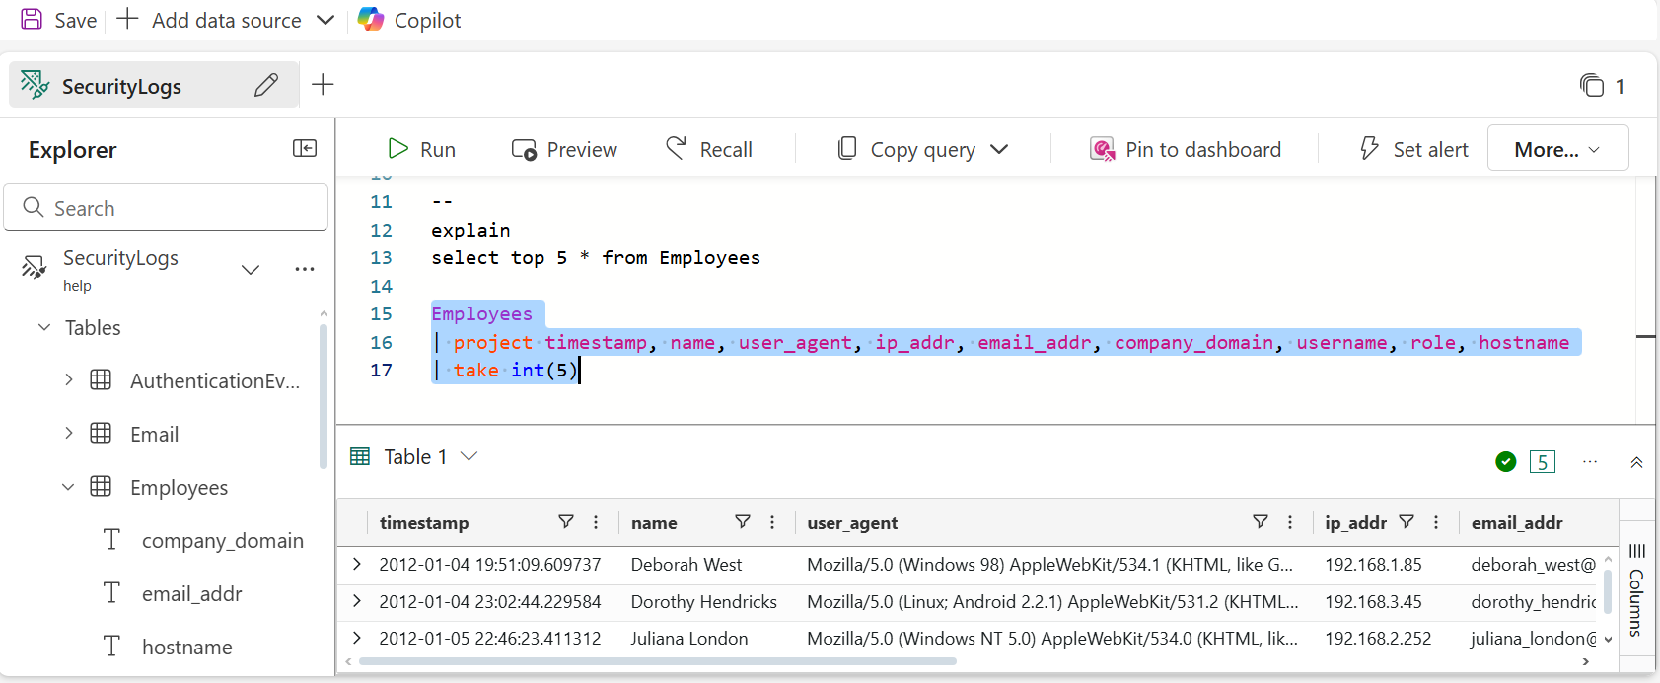

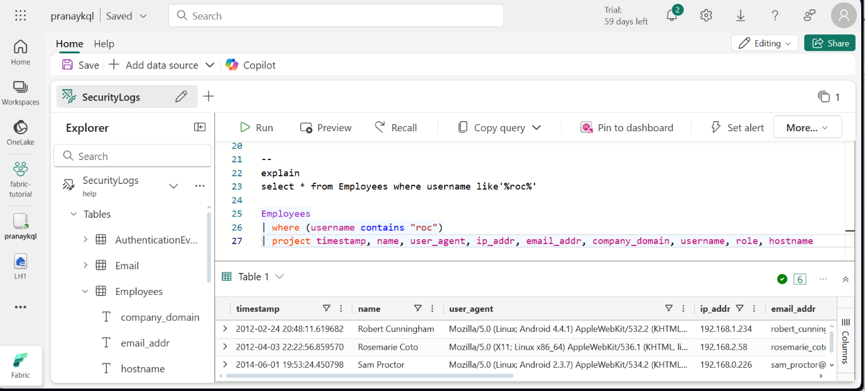

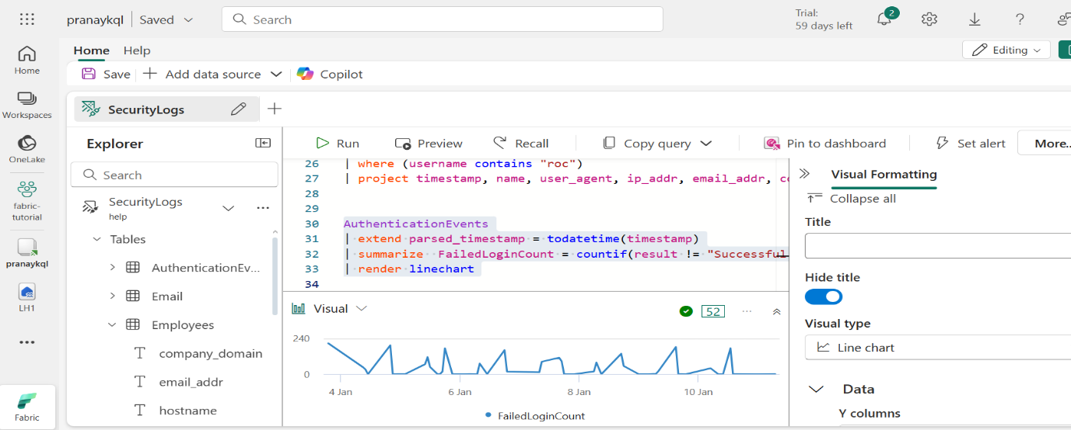

**INTEGRATION OF KQL WITH MICROSOFT POWER BI**

